SIMATS ENGINEERING (SAVEETHA SCHOOL OF ENGINEERING) Department of Computer Science and Engineering
ASSESSMENT TOOL 2 – Pseudocode Writing Task
Course Code: | CSA06 | Course Title: | Design and Analysis of  Algorithms
CO Assessed: | CO5 – Naturalization (BL5, BL6) | Assessment: | Assessment Tool 2 –  Pseudocode Writing Task
Weightage: | 30% of CIA | Total Marks: | 100
CO5 Statement: | Analyze computational problems using backtracking techniques and complexity classes such as P, NP, NP-Hard, and NP-Complete for combinatorial problem solving.
Student Name: | RAFEEZ AHAMED | Reg. No.: | 1925240478
Section / Batch: | AIDS/2025 | Date: | 25.08.26

Instructions to Students
• Answer the following question with proper pseudocode and logical explanation.
• Clearly specify the algorithmic approach and complexity class wherever applicable.
• Use proper asymptotic notation (Big-O, Big-Θ, Big-Ω) for complexity analysis.
• Include state-space representation, recursion steps, and pruning conditions in backtracking problems. • Neat presentation and step-by-step justification are mandatory.

Question Type | Focus Area | Questions
Pseudocode Writing Task | Analyze combinatorial problems using backtracking and complexity classes such as P, NP, NP-Hard, and NP-Complete. | Q1

SECTION A – Pseudocode Writing Task
Code of Conduct
I __________________________ (Name / Reg No) certify that this submission is my original work and that I have adhered to the guidelines specified for this assessment. I understand that any violation of academic integrity rules will result in disciplinary action.
Signature of the Student: _________________________

RUBRICS FOR CALCULATION
Criteria | Weight  age | Level 4 –  Exemplary | Level 3 –  Proficient | Level 2 –  Developing | Level 1 –  Beginning
Problem  Understanding | 20% | Identifies all inputs, outputs, constraints accurately | Minor missing  elements | Partial  understanding | Incorrect  interpretation
Algorithm  Design | 30% | Complete, correct, and logically sound solution | Minor logical gaps | Partially correct logic | Incorrect  approach
Use of Control Structures | 20% | Efficient and  appropriate use of loops, conditions,  functions/modules | Minor inefficiencies | Limited or basic usage | Incorrect or  missing  constructs
Pseudocode  Structure | 10% | Well-structured,  clear, consistent  format, easy to follow | Mostly clear with minor issues | Difficult to follow in parts | Poorly  structured  and unclear
Completeness | 20% | Handles all cases; optimized approach | Handles most  cases; reasonable efficiency | Handles basic  cases only | Incomplete or inefficient

Marks Evaluation:

Criteria | Wt. | Level 4 –  Exemplary | Level 3 –  Proficient | Level 2 –  Developing
Problem Understanding | 20%
Algorithm Design | 30%
Use of Control Structures | 20%
Pseudocode Structure | 10%
Completeness | 20%
Total Marks (100):

Level 1 – Beginning

Faculty In-charge | Course Coordinator | Head of Department
Name: | Name: | Name:
Signature: _______________ | Signature: _______________ | Signature: _______________
Date: ___________________ | Date: ___________________ | Date: ___________________

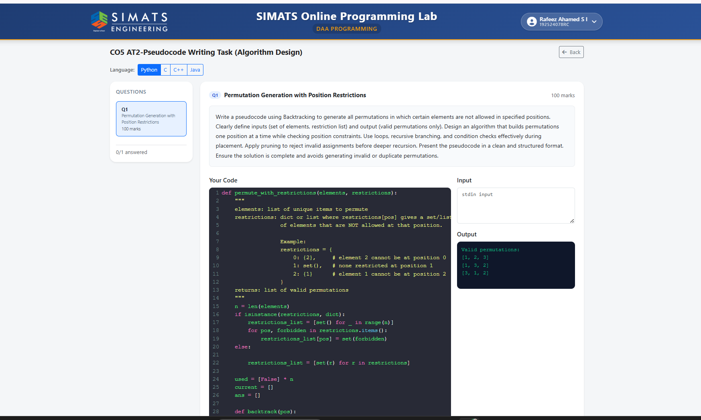
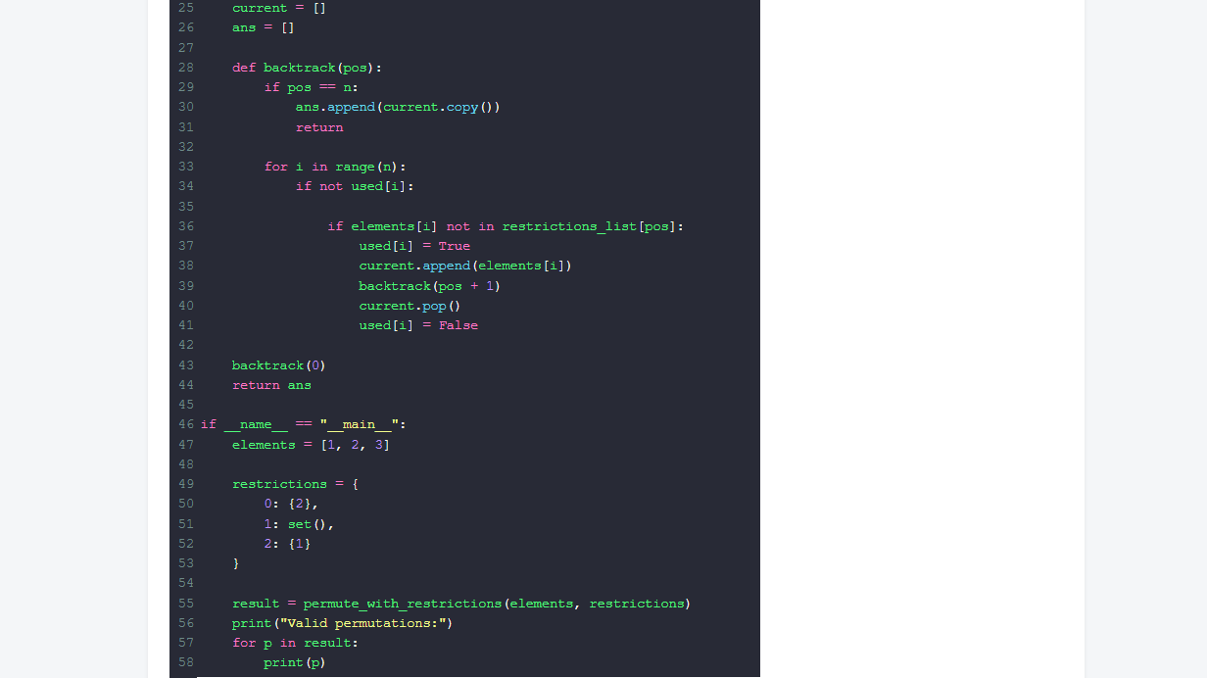

Q1 Permutation Generation with Position Restrictions

Write a pseudocode using Backtracking to generate all permutations in which certain elements are not allowed in specified positions.

Requirements:
- Clearly define inputs:
  - a set/list of elements
  - a restriction list/dictionary that specifies which elements are forbidden at which positions
- Clearly define output:
  - valid permutations only (no forbidden position placements)
- Design an algorithm that builds permutations one position at a time.
- Use:
  - loops to try candidates
  - recursive branching (backtracking)
  - condition checks to verify constraints
- Use pruning to reject invalid choices before deeper recursion.
- Present the pseudocode in a clean and structured format.
- Ensure it is complete and avoids generating:
  - invalid permutations
  - duplicate permutations

- Permutation generation with position restrictions means arranging all given unique elements while ensuring that some elements are not placed at specific positions. Backtracking builds the permutation step-by-step: at recursion level pos, it chooses one unused element and places it at that position. Before going deeper, the algorithm checks the constraint for that position (pruning): if the chosen element is forbidden at pos, that branch is rejected immediately, preventing invalid permutations from being generated. This continues until pos reaches n, at which point a complete valid permutation is added to the output. The recursion tree explores different candidate choices, while the used array guarantees that each element appears only once, ensuring no duplicates for unique inputs.
- The question is:

